Advanced Mechanical Design, University of Rochester
Final Design Report
Spring 2022

Novel Locomotion robot

Ali Mganga | Cristian Ramos | Jason Kahn | Vision Aryal

Abstract
This interdepartmental project between Mechanical and Electrical engineering seniors at the University of Rochester focuses on locomotion of a robot powered by linear actuators. The robot, about two feet in diameter, was manufactured out of plywood, PVC, and 3D printed ABS plastic, and joined together with epoxy. Following a Rhombicuboctahedron shape, 16 linear actuators were placed along select edges to allow for movement in various directions. The actuators create movement through a rack and pinion system, powered by DC motors. Designs and simulations were created in NX to determine materials, motor requirements, and size. Currently, this robot is being used to traverse open and flat terrain. Future applications could consider obstacles and steps.

Problem definition
Problem Background
NASA brainstorms ideas for potential rovers for other planets that have new and novel designs. These designs utilize new ways to solve problems that are specially adapted to a particular environment. Previously, rolling robots manipulated their center of mass to invoke rolling motion. The goal is to design and manufacture a robot which deploys linear actuators to invoke a rolling motion to navigate an environment.​

Problem Statement
Current robots and vehicles utilize locomotion that is not advantageous to certain environments. Use of wheels or shifting center of mass run into problems traversing obstacles. Other novel ideas could exist.​

Observations/Shortcomings
- Current methods of locomotion face difficulties over certain obstacles.​
- Rolling locomotion can allow for more precise movements around and/or over obstacles.​
- Previous rolling robots manipulated their center of mass to create motion.
- Limited acceleration is produced from this method.​

Opportunities/Gaps:​
- Omnidirectional movement​.
- Proposed technology is relevant towards current
engineering problems.

Requirements, specifications, deliverables
Deliverables:​
- Prototype robot​
- Written report​
- Theory of operation manual​ – See appendix
​
Initial Requirements:​
- Locomotion of the robot should be novel​.
- General geometry of the shape will be a regular geometric object​.
- Actuators that allow pivoting on sides.​
- Power source inside chassis (non-Tethered)​

Initial Specifications:​
- Cost no more than $1000.
- Robot no larger than 4-feet
- Inside volume no smaller than 8' x 11' x 4' - electrical equipment.
- Chassis weighs no more than 40lbf ​.
- Center of gravity stays within 0.5'.
- Worst case floor angle of 20 degrees - assuming coefficient of friction of 0.3.
Concepts
Geometry of the Chassis
Multiple concepts were considered during the initial stage of chassis development. The team decided to stick to a semi-symmetrical shape and each member contributed by bringing up one unique shape and presenting the pros and cons. The 4 shapes that were considered are hexagonal elongated bipyramid, truncated octahedron, square-orthobicupola, and a small rhombicuboctahedron. The prototyping of each of the shapes was made from cardboard, which allowed us to quickly simulate and understand the feasibility of each shape’s movement and shortcoming. The cardboard prototypes of each shape can be seen in Figure 1 below.
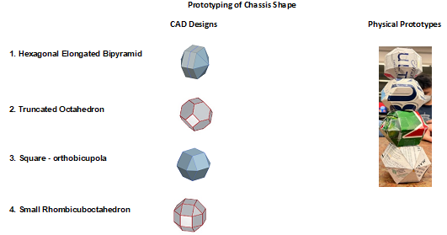
Fig. 1: Four geometries initially identified. Design 1 was the initial design given by the Electrical team.

After discussion with the Electrical team, these 4 designs were checked off and a Pugh matrix was created in Table 1 to select the most optimal final shape for the chassis.

Tab. 1: Pugh matrix for geometry selection. Ranked 1-3, where 3 is highest.

The matrix followed five different criteria: ease of manufacturing, cost of manufacturing, ease of movement, number of actuators needed for optimal movement, and possible direction of practical movement. The five criteria are factors that the Mechanical Engineering team and our sponsor foresaw as the most crucial aspects of chassis selection. Design 3 (square – orthobicupola) was initially selected as the optimum design because it met most of the criteria that were set for the robot. Design 3 also has a more overall-symmetrical structure, in addition to containing little to no shape abnormalities, these two reasons made us more confident in our design selection mainly because we foresaw an easier time with manufacturability. Lastly, design 3 was observed to be the most ideal for maneuverability since it allowed for 2 linear movements on the rectangular faces of its shape.

Actuator Development
After selecting Design 3, an NX CAD model was created to simulate movement and to capture the feasibility of adding actuators to stimulate robot maneuverability. The three possible areas that were considered to place actuators are the faces, edges, and vertices. It was decided that placing the actuators on the faces could result in structural issues through the consideration of the locus of rigidity. The locus in this case is the location of greatest stiffness against applied forces on a body. Overall, the faces of the chassis can cause rigidity issues due to the faces not being able to sustain the linear movement. The two remaining considerations for placing the actuators are either on the edges or placing them on their vertices. The team decided to move towards putting the actuators on the edges over the vertices, because both methods accomplish the same movement, and edge placement requires fewer actuators.
After selecting Design 3, the team decided to do a full NX Simulation of the structure and placed magnification on maneuverability, and feasibility, and considered other design limitations. A major shortcoming was identified with design 3, however. From a geometry analysis, it was found that the actuator length for design 3 needs to be equal to the radius length of the shape to stimulate robot movement. This is not feasible because the robot will need to house the electrical equipment, leaving no room for actuators to extend all the way to the center of the body. Investigating other geometries found that an octagon profile only requires an actuator length of 41% of the radius to produce a valid pivot. With an octagonal shape, there is also room for additional actuator length that allows for incline maneuverability, while still leaving room for electrical equipment. Unfortunately, this shape change increases the number of actuators required to 16, as there are more edges. To reiterate, the final design for the robot is a chassis with an octagonal shape (design 4 from figure 1) which is a small Rhombicuboctahedron. Upon selecting design 4, a complete Frankenstein model simulating dynamic movement in all directions was performed in addition to the following analysis: structural FEA (torque on rack and pinion), tolerancing (motor assembly brackets), and mechanical (stress in the rack). A complete breakdown of each analysis can be found below in the report.
The team really struggled with the actuator and motor selection aspect of the project which ended up taking several weeks to finally agree on. Uncertainty was expressed by both the Mechanical and Electrical Engineering teams and the topic of actuators became a constant focus in our meetings. The possible actuator types that were considered for a significant part of the project were pneumatic and electric actuators. The idea of manufacturing any of the actuators listed above was set aside because it would be very time-consuming and difficult to design and properly fabricate from an engineering perspective because we anticipated constantly dealing with fundamental design issues such as tolerancing and energy source. When selecting the actuators, the principal factors that we had to consider especially for the purpose and application of this project were power source and energy, force and strength, load capacity, mounting style, torque, and speed. The most optimal option would be to find a mechanical system online that met each criterion; however, as can be expected the greater we increase the specifications for each criterion, the more expensive the actuators are listed. It was already challenging because even with a system that was basic, slow, and inefficient for the application we were seeking, the actuators were expensive. We decided to consider other mechanical systems that we could use as actuators including rack and pinion and crank and slider.
Rack and pinion system is the most familiar, and a simple method of creating linear movement. Several analyses were performed to develop our own rack and pinion system, as detailed later in the report.

Material Selection
To conclude our selection and conceptual process two small yet very crucial parts of the design process had to be considered, material selection and manufacturing. Material selection is important because it allows engineers to optimize design while minimizing factors of interest such as material cost, time and ease of manufacturability, and environmental impact (sustainability). Material selection also allows for maximizing mechanical, chemical, and physical characteristics (durability, thermal properties, and structural integrity). It is in the best interest of Engineers to thoroughly inspect every stage of the material selection process of a product so that these characteristics are optimized and carefully selected for the applications of the product. Lastly, both material selection and manufacturing play a significant role in the feasibility of the project, and major considerations were given to each. In the material research aspect of the project the team had already developed ideas for the material we would use for each unique part (rack and pinion, chassis, and mounting block) but further research was done by searching for robot designs and gathering inspiration via online basic searches. There were multiple options that presented themselves and after which the team decided to further discuss our options with a local material expert.
The team scheduled a sit down with John Lambropoulos, a Professor of Mechanical Engineering, specializing in Material Science, to discuss material selection for the chassis and the robot subparts. For the chassis, the team decided to select Birch plywood for the outside robot skeleton and PVC for the edge and side connectors of the different faces. The combination of Birch plywood and PVC gave a unique characteristic to the chassis including ease of manufacturability, strength, stiffness, and rigidity to support all the stresses that will be occurring during movement. These two materials would also most likely be joined together with adhesives, such as epoxy. For the rack, acetal plastic was chosen for its low cost. However, steel reinforcement is required and talked more in-depth in the next section. The material for the pinion was less important, if it meshed with the rack, and would fit on the motor shaft. Finally, for the motor assembly mounting blocks, softwood was chosen as it can easily be worked with. All material selections for chassis, rack, mounting block, and pinion can be found in Table 2. All materials were purchased via McMaster Carr, the Home Depot, and Pololu Robotics and Electronics.

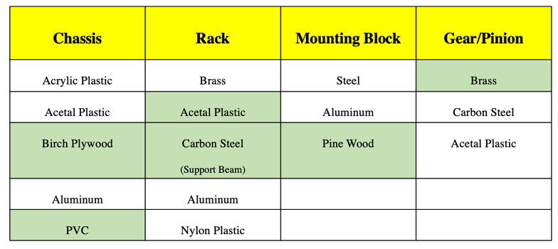 Tab. 2: Material selection chart for major robot parts.
Mechanical Analysis
Rack and Pinion Analysis
Going with the concept of a rack and pinion system for the actuators, several analyses were performed. First off, stress analysis was done using finite element modeling and simulation to determine what type of rack was required. Racks could be made from plastic or metal. Plastic racks are more suitable for the budget, so analysis was performed on an acetal plastic material. Of which, the least expensive acetal rack was chosen, and the CAD file was obtained from the vendor McMaster. This rack has a module of 0.8, which is important for pinion selection later. Research found that acetal plastic has an average yield strength of about 59.5 MPa (8630 psi) [1].
A few different loading cases were performed on the rack to observe whether the plastic will yield during the actuator’s movement. Statically, if the robot were to roll on a flat surface, there is more weight on the actuator at the start of its movement. This is because the center of gravity is equidistant to the actuator, as it is to the pivot side, as seen in Figure 2.

y
x
+

W

F_{A}
F_{P}
A
N_{p}

Fig. 2: Free Body Diagram of robot at start of movement.

Analyzing the moment equation about the pivot (orange), the following relationship can be made for the force on the actuator, A
$$\sum{M_{P}=0} (1)$$
$${-A}_{y}*x_{a}+W*x_{w}=0 (2)$$
$$A_{y}=W*\frac{x_{w}}{x_{a}} (3)$$
Where x_{w} and x_{a} are the distances of the weight and actuator force from the pivot, respectively. With an octagon geometry of two feet in diameter, each face is 10 inches in length. Thus, x_{a} is 10 inches and x_{w} is 5 inches.
$$A_{y}=\frac{1}{2} W (4)$$
With an angle of contact of 67.5 degrees, the full reaction force A can be found.
$$A= \frac{A_{y}}{sin(67.5°)}=\frac{W}{2*sin⁡(67.5°)} (5)$$
Since the overall design was incomplete before this statics analysis, the weight was assumed from the specification for a maximum weight, W, of 40lbf. From this, the maximum force on the actuator is 21.6lbf. This value, however, changes throughout pivoting. As the robot rolls over, the angle of contact changes, and the ratio of the weight distribution between x_{w} and x_{a} decreases. Right before tipping, the length of the actuator is at its max. This value is about 5.8 inches for an octagon diameter of 26 inches. The angle of contact is also at its minimum of 45 degrees. This longer length, and lower angle increases chances for bending. However, the normal force on the actuator at this point is close to zero, due to the center of gravity being positioned above the pivot, which can be seen in Figure 3 below.

W

A
N_{p}

Fig. 3: Free Body Diagram of robot at tipping

To first check if the acetal rack will not yield during extension, equation 3 was used for a chosen actuator extension case of 1 inch. Inputting the contact angle and force into the simulation, the following figure 4 was produced.
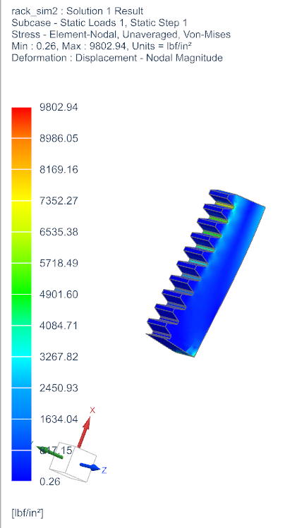
A
Fig. 4: Stress analysis of acetal rack extension at 1 inch. Applied load of 15.35 lbf at 62.7 degrees contact with ground. Fixed constraint on top edge – representing rack fixture in motor assembly.

From the figure, the max stress is around 9800 psi. This is well over the 8630psi yield stress for acetal. Since the plastic rack is quite inexpensive, methods of reinforcement were investigated. Using a 1005 steel beam of 3/16” x 3/16” cross section was identified as a potential reinforcement. Similar stress tests were performed on the steel reinforcement, varying the angle of contact and extension length of the actuator. In all simulations, the steel proved to be strong enough, as the element-nodal von-mises stress did not exceed steel’s yield stress of 33ksi.

Torque Determination
Working in parallel with the material selection and design for the rack and pinion system, a motor also had to be selected. A mechanism simulation was created to determine the torque required to lift the robot. For the simulation, a weight of 40lbf was assumed. A rack and pinion mechanism were developed in a NX simulation and it was driven by a rotation profile on the pinion. This setup is shown below in figure 5.
Fig. 5: Side profile of the robot movement. One rack and pinion mechanism setup to interact with the robot body and ground.

When selecting a motor, a lower torque is preferred as it will be smaller and less expensive. To produce a lower torque requirement, a smaller pinion diameter was desired. A 12.8mm pitch diameter pinion was first chosen for the simulation. The torque requirement for this pinion was about 5lbf-in. This information was handed to the electrical engineering team, who were able to find a motor to this specification. The motor selected had a D shaft, which means the pinion needed to match that, or have a pin to secure it to the shaft. The first pinion selected did not have a way to secure it to the shaft. A brass pinion with a 13.6mm pitch diameter was identified as the next smallest pinion that could be secured to the motor with a set screw. The updated torque requirement shifted slightly, requiring a max torque of around 5.2lbf-in, as plotted below in figure 6.

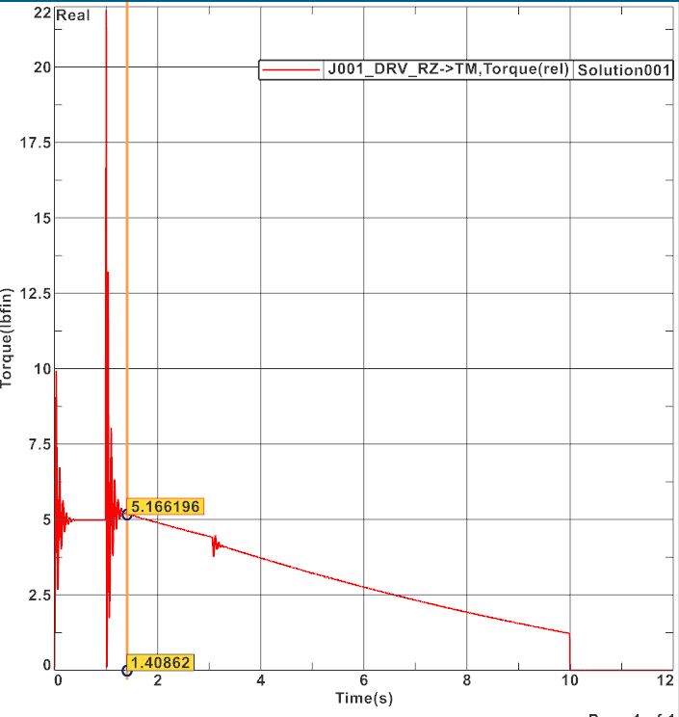
Fig. 6: Torque requirement from motor during one pivot motion. Note that the initial spike before movement can largely be ignored, as it is due to the initial contact between the actuator and the ground.

Although the chosen rack is plastic, and the pinion is brass, the team concluded that the robot will not be running frequently enough to worry about stripping of the plastic teeth in the rack.

Actuator Assembly Analysis
Due to wood being the primary material of the actuator assembly, variability was taken into consideration. This in return impacted the tolerancing of the slit cut along the block for the rack and steel bar system. After some initial tests of the assembly setup, we noticed a problem with an excessive force being applied to the rack when contacting the ground which eventually translated this force to the motor making it stall. To counterattack this force, a bracket was designed to go across the slit and constraint the rack. Inputting this bracket into the assembly added another factor of tolerancing in which the height and width of the bracket must result in a sliding fit for the rack and metal bar system. To determine if the bracket would fit, a tolerance analysis was calculated given the tolerances and dimensions (width and height) of the rack, steel bar, and slit in the wooden block.
A worst-case tolerance analysis was used to compare the upper and lower tolerances of each part to determine if these parts would fit.
For height, the lower limit tolerances of both the slit and bracket were compared to the upper limit tolerances of both the steel bar and rack. The respective values are as follows,

(0.140+0.350) in > (0.193+0.292) in,
0.490 in > 0.485 in

The equality proves true, therefore, given the worst conditions in terms of height the parts would fit, allowing the bracket to secure the rack and steel bar.
For width, the lower limit tolerances of both the slit and bracket were compared to the upper limit tolerances of both the steel bar and rack. The respective values are as follows,

(0.190+0.232) in > (0.202+0.193) in,
0.422 in > 0.395 inches

The equality proves true, therefore, given the worst width conditions, the part would still fit, allowing for the rack to smoothly slide along the slit and bracket.
Based on these results it became clear that 3D printing the bracket would suffice in constraining the steel bar and rack system and prevent a force to be placed on the motor.
Manufacturing
In this interdisciplinary project, there were two aspects the mechanical engineering team was responsible for: the chassis and the actuator systems. Two of our main concerns from the start were our material choice and cost due to the budget of $1000. The mechanical analysis that was done on our proposed concepts influenced the type of material selected and the most efficient way to manufacture each piece.
4
Actuator Assembly
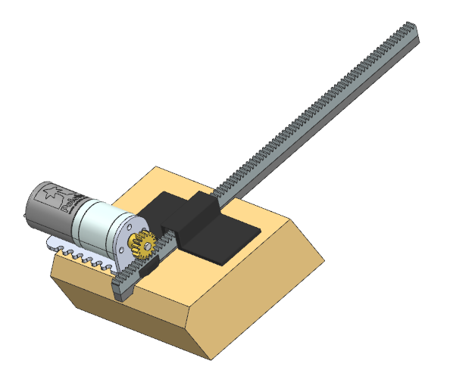
3
1
11
8
6
7
5
2
Fig. 7: CAD rendering of actuator assembly.

The actuator assemblies consisted of 8 major parts (excluding screws), as seen in figure 7 above, and in the motor assembly drawings of the appendix. Drawing 0a0003 displays all components that make up the assembly: parts 1, 3, 4, 6, and 8 were all purchased and parts 2, 5, and 7 were manufactured.
The mounting block (drawing 0c0010) is the main foundation to this assembly and was one of the main issues when it came to manufacturing. Initially, the proposed material for the block was plastic due to having the advantage of using CNC machining to efficiently provide the necessary dimensions. However, after the initial concepts and forecasting costs, it became clear that using plastic would not be financially smart as the budget needed to be allocated to more costly materials. Therefore, this led to choosing a cheaper option, in which wood became the chosen material for this mounting block. Although wood has some variability in size and flatness, as well as a higher friction coefficient than plastic, its easiness to work with was favored. To limit the effects of friction, since the rack will be sliding along the wood, wax will be added to the surface.
To be time efficient, a procedure was created based on manufacturing a single block from the start. A 2in x 4in. x 8ft whitewood stud was purchased to be cut into 16 identical blocks. Since the mounting block has a cut at an angle of 67.5°, the miter saw was setup using the complementary angle of 22.5°. Using calipers, the wood was sectioned into 3.5-inch pieces. Next, the table saw was used to create a slit along the block which would allow the rack and steel bar assembly to slide through. The table saw blade was lowered to be at a height roughly about 0.145 inches, which was measured from the table to the highest peak of the blade. The blade thickness was smaller than the necessary cut needed. Therefore, the block was run through the table saw twice to create the correct measurement of the slit. Finally, the bottom corner of the mounting block had to be cut off so the rack could line up with the middle of the PVC edge. A distance of 0.4 inches was measured to be removed. This cut was made by setting the table saw at an angle of about 35 degrees. With no table saw available, the cut could easily be made by using a belt sander as well. This entire process was repeated 16 times and material was purchased in excess in case some parts were not within tolerance.
The bracket (drawing 0c0012) was designed after our initial testing and was 3D printed. In addition, the ramps (drawing 0c0016_LSRamps) as a solution to the limit switches was also 3D printed. This was thought to be the best option as the project deadline was approaching and their small size would make it difficult to manufacture in the shop. Therefore, to save time, money, and to place focus on other issues, these parts were 3D printed.
The steel supports (drawing 0c0011) were attached to the rack (drawing 0c0009) using a two-part epoxy. This epoxy was also used to attach the ramps onto the side of the rack.

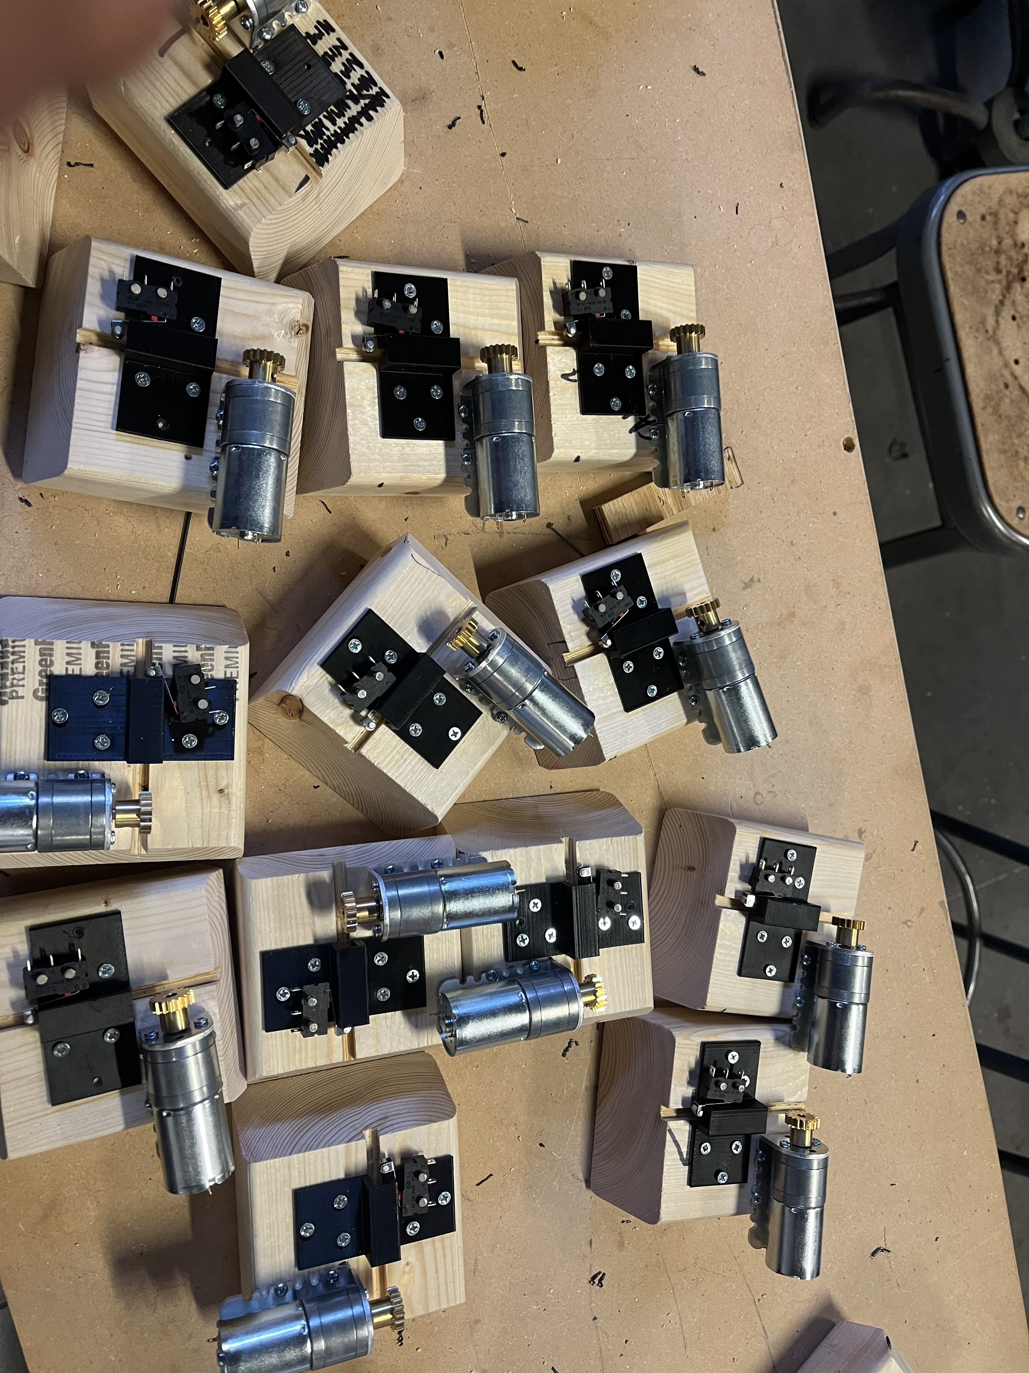
Fig. 8: Finished product of most actuator assemblies.

Chassis

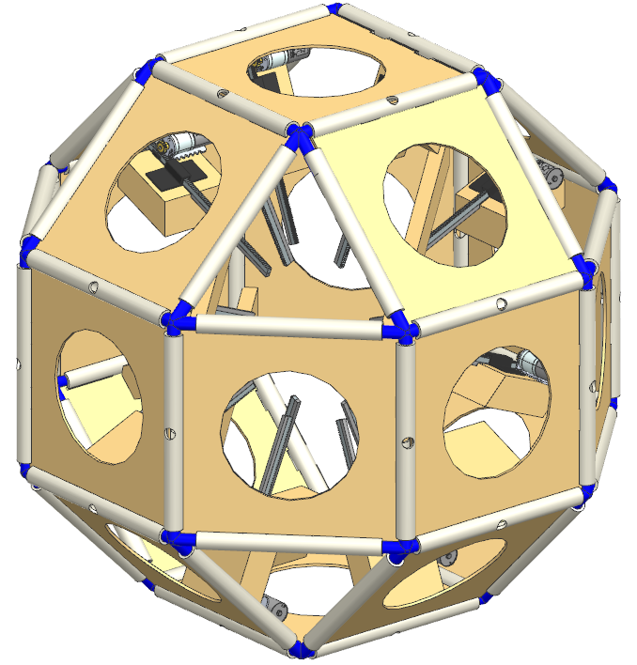
3
2
2
1
Fig. 9: CAD rendering for main chassis assembly. Main components labelled.

As seen above, the main body of the robot is made of 1/8” plywood for the faces (1), ½” PVC for the edges (2), and 3D printed joints made of ABS plastic (3). Manufacturing of the frame involved repeated processes of cutting, milling, printing, and assembly.
The faces (0c0005) were chosen to be made of 1/8” birch plywood because it is lightweight and can easily be fabricated using a laser cutter. These faces were a little less than 10 inches in length on either side and had a slot pattern along the edges, to line up with complementary slots in the PVC sides. See drawings for parts 0c0001, 0c0002, and 0c0005 in the appendix for specifics of how the slots were arranged. Most of the faces had a 6” diameter hole cut in the middle to reduce weight and allow for ease of access inside the robot once assembled. Three faces, however, did not have holes cut in them, as they were designated to have electrical equipment mounted to them. These solid faces also doubled as spots to add a name and University logos to the robot.
The PVC was chosen because it is rigid in short sections and is primarily used to mount the plywood panels at specific angles relative to one another. The PVC was first cut into 24-8” and 24- 9” sections. The 8” sections lie along the triangle faces of the chosen geometry, and the 9” sections lie along the square faces. Once cut, each PVC was placed in the mill and a 1/8” end mill was used to create the complementary slots to where the plywood would be inserted. For the 9” sections that required slots for two separate panels, a fixture was designed to set the PVC at the correct angle of 135 degrees in the vice after the first cut was made. This angle is based on the geometry of an octagon. The profile of this fixture can be seen below in figure 10a, where the first slot made from the mill is inserted into the flange. The second slot can then be made along the top edge.
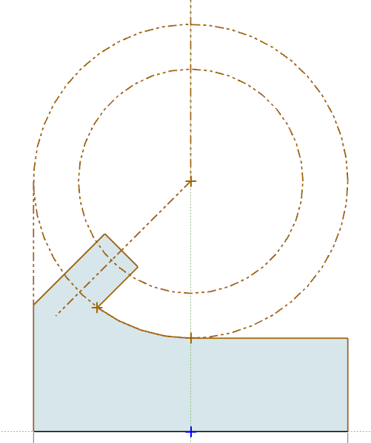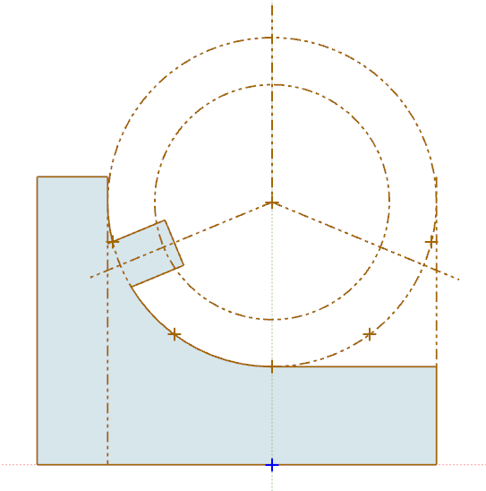
135º
135º
Fig. 10a & 10b: Two fixtures made for cutting PVC. Sketches of the PVC profile were made, including the position of the slots. Left (7a) used to create second slot. Right (7b) used to create hole. Both fixtures 3D printed and secured on parallels in vice.
Additionally, 16 of the 9” sections were selected to drill about a half inch hole through the middle of the PVC, which would give clearance for the actuator to pass through. The PVC was set up in the vice by using a second, but similar, fixture. This setup can be seen in figure 10b above. The hole was cut down from the top using a 17/32 drill bit.
The corner joints were developed from geometrical analysis of a wireframe model of the chassis. In CAD (NX), cylinders were extruded 2 inches along each edge, with a diameter 0.02” less than the inside diameter of ½” PVC. Twenty-four of these corner joints were 3D printed with an ABS filament.
Once all the components were manufactured, the chassis was put together using a two-part epoxy. The chassis was assembled separately in two halves. For ease of access to the inside of the robot, the top half of the chassis was not epoxied, and tape is used to hold the complete chassis together. Both halves of the chassis are rigid enough, and there is enough friction between the plywood, PVC, and corner joints, that the top is quite secure without the epoxy.
Further work on the chassis involved installing four cross supports across the solid panels of the robot. These are 1x2 wood beams cut to length and will be used to secure the electrical equipment to. Additionally, ¼” thick neoprene foam was added to all the edges to allow for smoother rolling of the robot.

Cost
Manufacturing hours were estimated for the development of the robot. Generally, there were two groups of focus for the fabrication. Ali and Cristian worked on the motor assemblies, and Jason and Vision worked on the Chassis. The motor assemblies took more time than the chassis because they required tighter tolerances – thus being more expensive. Additionally, the team ran into issues with placing limit switches on the motor assemblies, as requested by the Electrical Engineering team. Once Jason and Vision completed the chassis, they were able to assist with the motor assemblies. The following tables list total prices for manufacturing hours, total hours (manufacturing and development), and bill of materials.
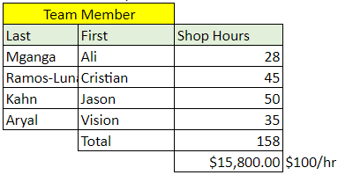
Tab. 3: Manufacturing Costs

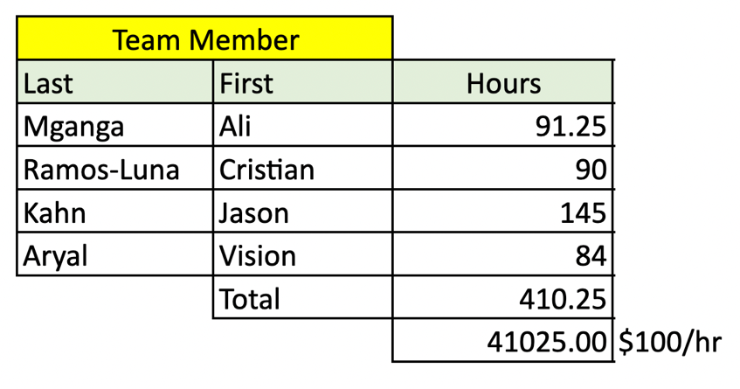
Tab. 4: Total Hours (Development & Manufacturing)

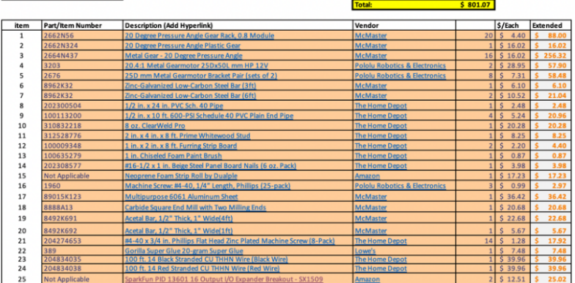
Tab. 5: Manufacturing Bills of Material. Larger image attached to appendix.
Overall, the robot required mass production of a lot of components. Creating 16 motor assemblies and milling 48 PVC edges took the longest time, as they required access to machines, which were sometimes limited. The square panels and corner joints, however, could easily be made during off-hours. Assembly for the Chassis took a long time, as time had to be added for the epoxy to cure before moving forward with further assembly. The motor assembly also took a long time, due to the precision of the limit switches and tight tolerances in the slot for the rack. If mass production was desired for 1000 units, automating the cutting of the PVC and mounting blocks would be required. Potentially redesigning the layout of the motor assemblies to include fixtures and holes that line up all the components at once would greatly help with the assembly. Additionally, a different adhesive with a faster set and curing time would be beneficial to saving time.
Test plan and results
Several tests were done to ensure that the robot met all the specifications defined at the start of the project. Below is a list of the specifications and the methods that the team used to test and refine each calculation and measurement needed to satisfy requirements and specifications.

Specifications:
- Cost no more than $1000 (NMR Budget tracker)
- To stay within the $1000 Budget, the team used a budget tracking tool that was handed to us by our project manager (Christopher Muir) via Microsoft Teams on the Senior Design project schedule NMR Excel file.​ The robot cost ~ $800 ($801.07) as of April 24, 2022. To keep track of our budget the team tracked and noted every purchase using the NMR file. It is important to note that before every purchase, different sites were searched to find the cheapest and most efficient products that met the specifications the team was looking for. When designing and purchasing products, cheaper materials such as wood and PVC instead of aluminum and steel were used to stay within our budget. As part of the purchasing process, the team had to submit a purchase request which had to be approved by the project manager, who assures the budget was being used in the best way possible for the project. Since $800 is less than $1000, this specification passed.

- Robot no larger than 4-feet (Tape measure from side-to-side)​
- The side-to-side dimensions are 25.5 inches and the maximum diagonal length between the two sides is 27.5 inches. This maximum dimension of the robot is within the 4 feet limitation, thus passing the specification.

- Inside volume no smaller than 8' x 11' x 4' - electrical equipment (Tape measure)​
- The center volume was found to be 8x8x8”. Although not exact to the original dimension-specification, this cavity size was updated per request from the Electrical Engineering team. The total center volume is larger and more symmetric than the original dimensions. All the electrical components fit well in the center of the robot, with room for the retracted actuators. See figure 16 in appendix for layout of electrical components inside the robot.

- Chassis weighs no more than 40lbs (Scale)​
- The weight of the chassis and the robot (including the electrical equipment inside) was measured using a normal weighing scale that the team had access to. The weight of the chassis was measured to be ~22.5lbs and the weight of the completed robot was measured to be 26.9 lbs. Since 22.5lbs is no more than 40lbs, this specification passed.

- The Center of gravity stays within 0.5' (Tape and Simulation)​
- The robot was balanced over a long PVC in three different dimensions. When balanced, the location of the PVC underneath the robot was marked. The same process was repeated after the robot was rolled along the x direction. The y and z coordinates of the center of gravity remained the same. Since the center of gravity stayed within 0.5’’, this specification passed.

- Worst case floor angle of 20 degrees - Assuming a coefficient of friction of 0.3 (Level it)
- Robot Sliding: The maximum angle that the robot could move without sliding can be found by using the coefficient of friction between the surface of the PVC and the floor surface. Assuming the coefficient of friction to be 0.3, the maximum angle was found to be 17 degrees. This specification was not met. This specification didn’t affect the performance of the robot because the primary application of the robot was on a flat surface. Some modifications must be made to the size of the robot and the length of actuators to move up/down an inclined surface. Additionally, after conversation with our sponsor, it was determined that the Electrical Engineering team were no longer interested in the application of testing the robot with an incline.

- Robot Rolling: Considering the geometry of an octagon, the maximum floor angle without rolling is 22.5 degrees. This is simply the angle between a horizontal and an edge, with the octagon positioned on top of one of its vertices. Any higher angle will result in the center of gravity swaying and producing a roll.

Additional Testing
- Testing of wood panel strength:
- A face of the robot was tested to determine if it would fail under the weight load of the robot. A weight of 35lbs was used to approximate the overall weight of the robot and was placed on edge of the PVC. This scenario mimicked the force the motor assembly would exert and forecast how the wood panel would react. Significant bending was seen on the wood, but no structural failure occurred. With more panels to be connected, this bending would be reduced as it would translate to other parts of the robot and not solely this panel.

- Initial testing of motor assembly
- When the first prototype of the motor assembly was complete, it was tested to verify if it would lift at most 40lbs. A power source measuring voltage and current along with free weights was used to test, as seen in figure 11. The weight was increased to see at what point the system would fail, for the first 27.5lbs the actuator system was able to successfully lift the weight. Unfortunately, at around 35lbs the motor started to stall and started to strip the rack due to the pinion and rack losing contact. The stall in the motor was a consequence of the rack translating excessive force on the motor when contacting ground. A bracket was designed to constraint the rack in the Z - direction and prevent a force being translated into the motor. After implementing this design, the system was tested again and able to lift 35lbs.
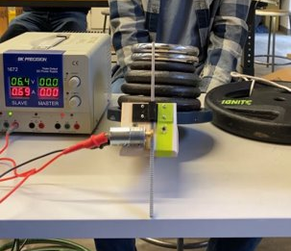
Fig. 11: Testing of rack and pinion system.

- Testing of the assembled robot for rolling:
- After completing the assembly of the robot, one of the actuators was tested to ensure that the robot would roll, as seen in figure 12 below. After successful completion, the team handed over the chassis to the electrical team. From there, the electrical equipment was installed. With this final weight, all actuators were then tested, and the robot was able to roll successfully.
Fig. 12: Successful testing of an actuator.
Soceital & Environmental Implications
Global, Cultural, and Societal Implications
The Mechanical and Engineering teams are aware that “Engineering has a direct and vital impact on the quality of life of all people” and it is within this core statement that both teams are interested in exploring possible solutions to the problem noted in the objective section of this project while exploring an interesting Engineering design challenge [2]. To reiterate the problem and objective of this project, current robots and vehicles utilize locomotion that is not advantageous to certain environments. The use of wheels or shifting the center of mass of a vehicle can run into problems of traversing obstacles. There are other novel ideas that could exist. To address this problem, the team proposes a design of a rolling robot that deploys linear actuators to invoke the rolling motion. Although not direct, the team realizes the relevant global, cultural, and social implications that this project addresses. After close analysis, the team has become aware of various factors that can be closely tied to the societal, economic, and environmental impacts of this project. Our proposed design utilizes technology that is relevant to current engineering problems pertaining to potential space exploration, traversing environments not feasible to humans, search and rescue missions and scientific improvement towards novel robot locomotion. Not all environments are reachable by humans, and they require specialized methods of locomotion to explore them. Our small-Rhombicuboctahedron design has many advantages including but not limited to the locomotion of the robot via omnidirectional movement which can be used to travel over rough terrain and able to operate at relatively high speeds. Additionally, the technology that we plan to develop could be relevant for many applications of space exploration that space organizations like NASA have been trying to expand on via ideas for potential rovers on other planets. All in all, our robot can be used in various applications but is not intended to replace human activity. On the other hand, our robots' intended societal application is to advance human knowledge through exploration so that the global community can become more informed of various environments through the scope of science and technology.

Ethical Issues
From an ethical standpoint, the team does not anticipate any breach of ethical guidelines and plans on utilizing best practices for all stages of design, mechanical and electrical integration, testing, and showcasing to University of Rochester peers. Both teams, Mechanical and Electrical, take the ethics and safety aspect of this project seriously and intend to stay within the guidelines of our respective disciplinary boards. The Mechanical and Electrical Engineering teams are staying within the general ethical principles of The National Society of Professional Engineers (NSPE) and The American Society of Mechanical Engineers (ASME) as well as The Institute of Electrical and Electronics Engineers (IEEE) and Association for Computing Machinery (ACM). At the very core NSPE and ASME code of ethics state, ``Engineering has a direct and vital impact on the quality of life for all people. [...] the services provided by engineers require honesty, impartiality, fairness, and equity, and must be dedicated to the protection of the public health, safety, and welfare” [2]. From the Electrical Engineering side, IEEE and ACM code of ethics simply state to “avoid harm”. To adhere to both standards both teams think critically about any potential unintended consequences of this project both by how we intend the technology to be used and how we fabricate, manufacture, design, test, and integrate electrical components. For the scope of this project, it is important that both teams are diligent and aware of all potential risks and harm that can be caused to people, animals, and property. For testing purposes, the team received proper testing areas for the robot to roll within confined spacing so that we can avoid damaging property and hurting any people or animals within the process. Both teams are trained and aware of the testing and manufacturing safety issues that present themselves throughout the project and are being cautious by following all Mechanical and Electrical engineering best practices to avoid hazardous situations. We would like to note that relevant guidelines within the Mechanical Engineering code of ethics were followed for designing and building the robot and our fabrication and testing process was indirectly supervised by University of Rochester staff and professors.

Environmental Impact
An Engineering design calls for close inspection of many factors but ultimately ergonomics, durability, cost, and manufacturing are usually the top factors Mechanical Engineers are interested in maximizing through all stages of ‘product life’. Material selection as it pertains to product life, as previously mentioned is important because it allows engineers to optimize product design while considering cost and environmental impact. The team took careful consideration in choosing material for the robot and centered decisions around the project budget ($1,000) and application. Ultimately, birch plywood, pine, PVC, acetal plastic, and brass encompass the major material selection criteria for our robot pieces which include the chassis, mounting block, rack, and gear/pinion. In retrospect, the team did not intentionally select these materials due to their environmental and sustainability contributions. For the most part, the materials selected for the robot fall in fair standings in the category of Strength (MPa) Vs. Embodied energy (MJ/m^3) and Density (kg/m^3) on the Ashby charts (figures 13a & 13b). As can be seen in Figure C (Strength Vs. Embodied energy) and Figure D (Strength Vs. Density) wood and plastic are within an average range of energy and amount used whereas Brass and other metals sit in a higher range of the spectrum. Essentially, the Ashby charts are indicating that the sum of all the energy and amount required to produce our materials are within a fair range except for the gears which are made of brass. Overall, however, our robot has a low environmental footprint. The robot’s primary material, wood, is often associated with deforestation. However, wood’s ability to be continuously harvested makes it not depletable to earth’s natural resources, leaving less of a carbon footprint than most of its counterparts (steel, ceramic, concrete, etc.) In addition to being renewable, wood is eco-friendly and at end of life can sometimes be recyclable via the use of biofuel a process that is already environmentally unsustainable.
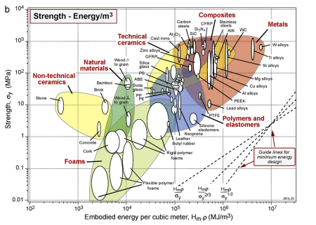
Figure 13a: Strength (MPa) Vs. Embodied energy (MJ/m^3)

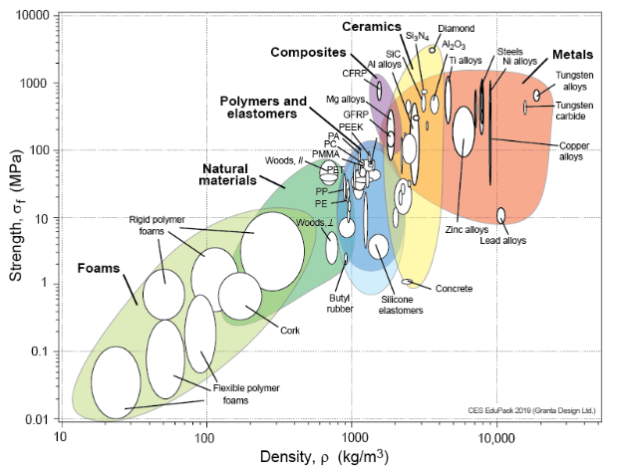
Figure 13b: Strength (MPa) Vs. Density (kg/m^3)
Intellectual Property
As it pertains to patenting, the team used the United States Patent and Trademark Office (USPTO) and Google Patents as the main source for collecting information on relevant existing patents, companies, and individuals that are working in areas like the concepts found in our robot. The team’s research efforts show that rack and pinion mechanisms are commonly used for steering in motor vehicles that stimulate movement through wheels. It appears that the idea of a rolling robot using linear actuators to traverse different environments has been patented by The Boeing Corporation, an aerospace company and leading manufacturer of various engineering sectors. From the basis of our problem statement, background, and intended application of our robot, it makes complete sense that Boeing Corporation has a similar idea that is patented within this line of robot application. Based on the USPTO, the Robotics all terrain surveyor (active patent number: 7,165,637) by Taniellan Minas and the Boeing Company is an invention/idea of “A vehicle including a body and three legs. Each leg includes a proximal end coupled to the body, a distal end opposite the proximal end, and an actuator. Each actuator imparts enough acceleration to the vehicle along an axis of the leg to cause the distal end of the leg to leave a surface upon which it rests. Thus, the robot can pivot around one leg when the actuator of another leg imparts an acceleration. One actuator may also cause two legs to leave the surface. Moreover, the actuators may be spring biased into a retracted position. Further, the body may be a Platonic solid and the axes of the lags may pass through the vehicle's center of gravity. Of course, the body could be a sphere while the vehicle could be a planetary robot or a toy. Methods of traversing a surface are also provided” [5 & 5a].
Another notable patent idea that is like both the Boeing Robotics all terrain surveyor invention and our (senior design) idea is the Multiple Leg Tumbling Robot by Adrian Gregory Hlynka and Christopher Gregory Hlynka. The Multiple Leg Tumbling Robot is “A robot or vehicle locomotes by tumbling. Legs distributed over the surface of the robot individually extend or retract. A control system coordinates the action of the legs to cause the robot to tumble in any direction. A robot using this form of locomotion is highly maneuverable, can climb slopes, and can step over obstacles. It can provide a smooth ride on rugged terrain. A variation can jump into the air and land safely. A variation can be built with as few as six moving parts, can fold to fit into a projectile, and instantly unfold on landing. It may use airbags instead of legs. It can include a video system without moving parts that produces a stable, non-tumbling view of its surroundings while tumbling. It is an ideal remotely operated vehicle for search and rescue, firefighting, or reconnaissance for the military or police” [6].
The main companies that file in linear actuators, rack and pinion systems, and robots are Honda Giken Kogyo Kabushiki Kaisha, Honda Motor Co., Ltd, Lockheed Martin, The United States of America as represented by the Secretary of the Navy, and Raytheon company. Additionally, the top inventers that file in this space include, Takashi Kubot, Roger d. Quinn, shuuji kajita, and Kazuya Yoshida.

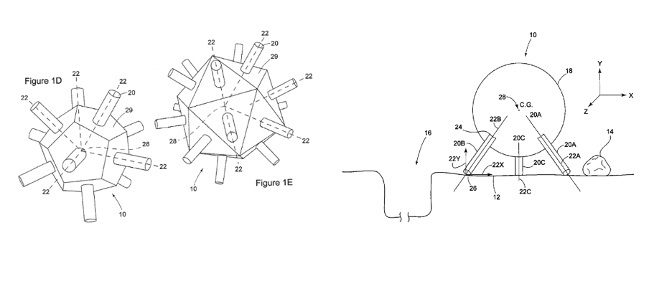Fig. 14: ROBOTIC ALL TERRAIN SURVEYOR

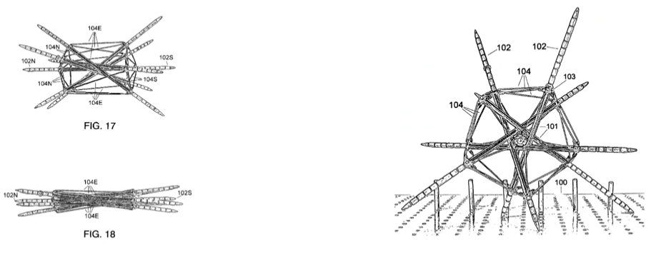Fig. 15: MULTIPLE LEG ROBOT
recommendations for future work
Further work could focus on a myriad of design changes. Starting with the chassis, weight reduction analysis could be done on the plywood panels to reduce weight as much as possible. Or perhaps even different material selection could be of consideration. Further structural and bending analysis could be performed to determine if more faces could be discarded and rely more on the rigidity of the PVC frame. As for the motor assemblies, more designing could have been performed to create fixtures that allow for consistent assembly of the bracket, limit switches, and motor onto the mounting block. Additionally, weight reduction analysis could be performed on the mounting block.
Alternatively, different systems of actuators could have been developed. Such as pneumatic systems, or something inspired by the multiple leg robot in figure 15 above. Actuators that span through the entire robot could have been used. Development of obstacle avoidance could also be implemented.
This project is a proof of concept for this novel locomotion. Although there are patents with similar ideas, this idea still has not been explored that much. More time and a larger budget could allow for quite a complex system that is able to withstand harsh environments and terrains.
Acknowledgments
Special thanks to Jim Alkins for guidance with machines and manufacturing in Rettner. Thanks to Anna Remus for assistance with operating laser cutter. Thanks to Professor Christopher Muir with helpful ideas during design. Thanks to Professor John Lambropoulos for insight into material selection. Important thanks to Jack Mottley and Electrical Engineering team for the development of the project idea.
References

[1] “Overview of materials for Acetal Copolymer, Unreinforced,” MatWeb, accessed April 24, 2022, https://www.matweb.com/search/DataSheet.aspx?MatGUID=c3039ef87c9245448cdebe961b19a54c&ckck=1.

[2] “Code of ethics,” Code of Ethics | National Society of Professional Engineers. [Online]. Available: https://www.nspe.org/resources/ethics/code-ethics. [Accessed: 21-Apr-2022].
[3] J. A. M. Allwood, M. F. Ashby, T. G. Gutowski, and E. Worrell, “Material efficiency: A white paper,” Resources, Conservation and Recycling, 2010. [Online]. Available: http://web.mit.edu/ebm/www/Publications/MEWP_Res_Cons_Recycl_2011.pdf. [Accessed: 21-Apr-2022].
[4] “Material property charts – Ansys Granta,” Material property charts. [Online]. Available: https://www.grantadesign.com/education/students/charts/. [Accessed: 21-Apr-2022].
[5] “US7327112B1 - multiple leg tumbling robot,” Google Patents. [Online]. Available: https://patents.google.com/patent/US7327112B1/en?q=~patent%2FUS7434638B2&scholar. [Accessed: 24-Apr-2022].
[5a] “US7434638B2 - robotic all terrain surveyor,” Google Patents. [Online]. Available: https://patents.google.com/patent/US7434638B2/en?q=actuator&before=priority%3A20070112&scholar. [Accessed: 24-Apr-2022].
[6] M. Taniellian, “United States Patent, Taniellian, Patent #: US007165637.”
Appendix
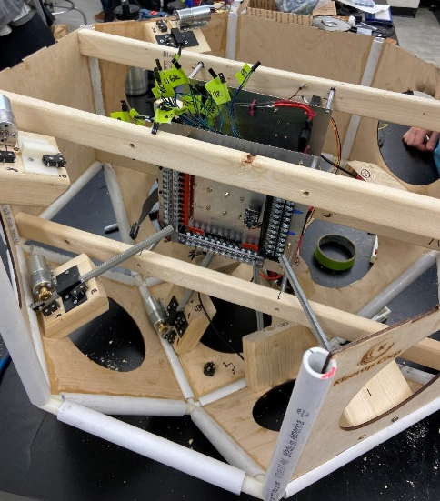
Fig. 16: Primary electrical equipment positioned inside the robot.

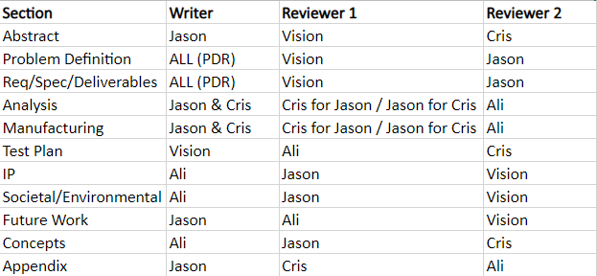
Fig. 17: Review process of Final Design Review. Separate revisions and version documents in FDR Drafts folder of NovelMovementRobot teams channel.

Bill of Materials (Tab. 5) attached at end of document.

Theory of operation manual attached at end of document.

All drawings for chassis and motor assembly attached at end of document.

Link to website: https://www.hajim.rochester.edu/senior-design-day/novelmovementrobot/

